Department of Computer Science
Forman Christian College University

COMP360: Introduction to AI
Fall 2021



Task 1 (2) | Task 2 (9) | Task 3 (9) | Total (20)

Lab 2: BFS and DFS Implementations and Comparisons

This lab is aimed to give you the opportunity to practice and observe the practical implementation of Breadth-First-Search (FBS) and Depth-First-Search (DFS).

Important Instructions:
- Lab Manual is self explanatory so read through this lab manual before starting the lab.
- You can use any of the Programming Language that you think works better for you in this Lab.
- You can get help from you friend Google But remember Copy and Pasting of the code is prohibited and is not a good practice.
- Every question asked in the viva will have marks, So make sure you understand what you write and should be able to explain the code.

Expected Deliverable:
- The Code File: File having the implementations of BFS and DFS
- This Word File: The same document file (Lab manual) you have the observed results that you will be filling in the following tasks.

Submission:
Zip your deliverable files and with your “Roll_Name_Lab2.zip” and submit on moodle

Experimental Tasks:
You need to perform the following tasks in order to qualify this Lab.

Task 1: Observe the following Tree. Consider that node having “1” is the root node.

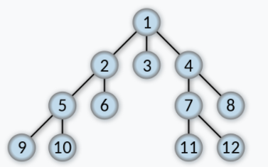

Task 2: Write the code for BFS, try the above tree node’s numbers as inputs and write down the results you observed.
1, 2, 3, 4, 5, 6, 7, 8, 9, 10, 11, 12,

Task 3: Write the code for DFS, Try the above tree node’s numbers as inputs and write down the results you observed.
1, 2, 5, 9, 10, 6, 3, 4, 7, 11, 12, 8,

Note: This is an individual Lab and Groups are not allowed.
Code Format:
Follow the following Code format.
Make Functions of BFS and DFS.
Make a Main test function to call the above functions.
Use any of the programming language you feel comfortable with. (Java, Python, C++ or anyother etc)

def BFS():
#code
#code
#code

def DFS():
#code
#code
#code

__main__ :
BFS()
DFS()

